CENWP-OD-B 01 August 2023

MEMORANDUM FOR THE RECORD

SUBJECT: 23BON073 MFR Adult Fish Facility Sockeye Mortality

The U.S. Army Corps of Engineers is reporting on the incident reported by the Columbia River Inter-Tribal Fish Commission and the potential impacts to fish and/or fish passage conditions at Bonneville Dam. This incident is not the responsibility of the Corps. We report it here for regional awareness.

On the morning of 01 August, CRITFC biologists notified Project Biologists of a Sockeye mortality. Upon scanning the fish for PIT tags it was found that it had been tagged in Bonneville’s Adult Fish Facility the day prior.

- Species – Chinook (Oncorhynchus nerka)
- Origin – Unknown
- Length – Approximately 49.5 cm.
- Marks and tags – Adipose absent - PIT tag 3DD.003E2BF2EC
- Marks and Injuries found on carcass – none
- Cause and Time of Death –
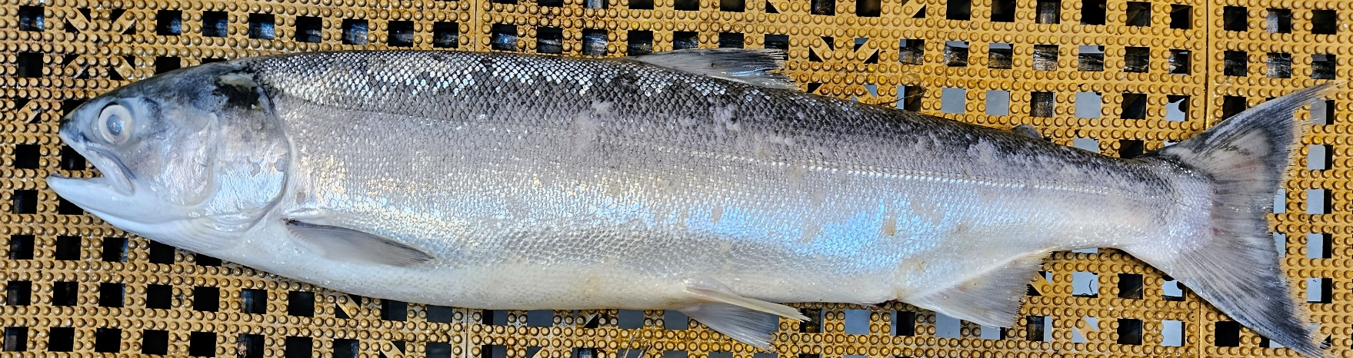
- Future and Preventative Measures – none

Sincerely,
Bonneville Project Fisheries

